**Name: Bulbul Singh**

**Reg. no: 19BEC1243**

**Date: 16-08-2021**

**EXPERIMENT NO: 3**

**Design and Troubleshooting of Clippers and Clampers**

**Aim:** To design clippers and clampers circuit using LTSpice tool.

**Software used:** LTSpice

**Components required:** Resistors, voltage source, capacitors, diode.

**Clipper:**

**Task 1:** +ve clipper at 2V

**Circuit:**

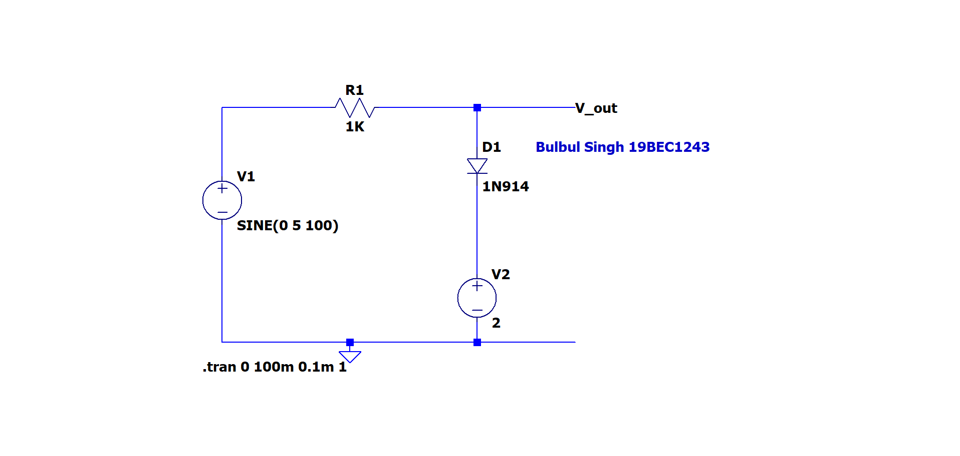

**Output:**

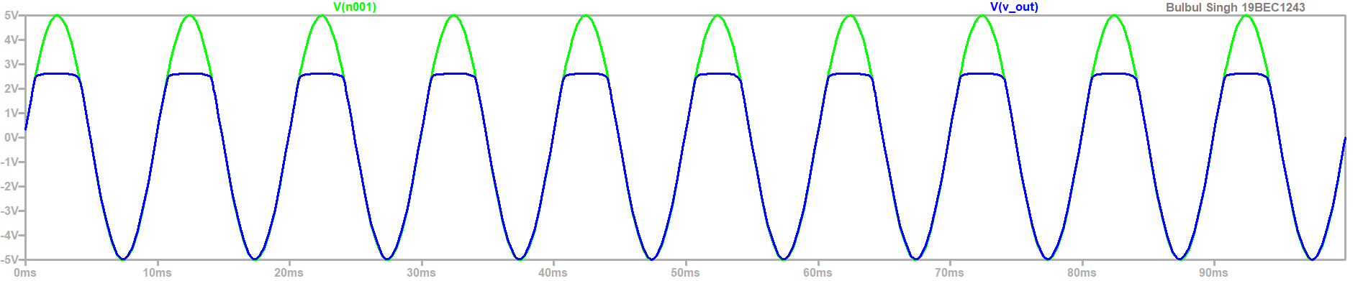

**Task 2:** Clip complete +ve cycle

**Circuit:**

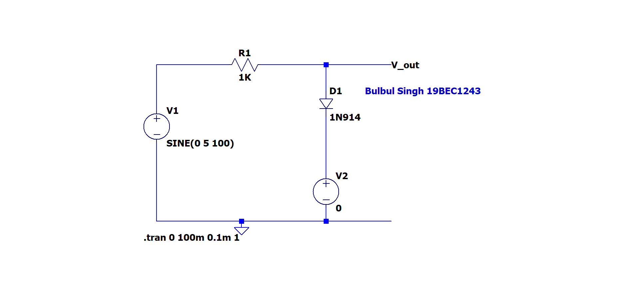

**Output:**

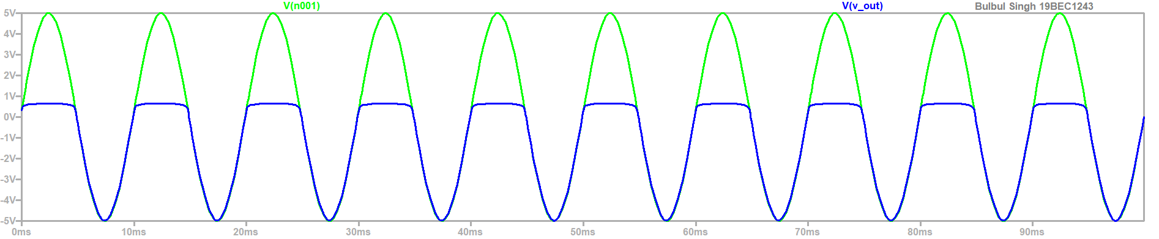

**Task 3:** -ve clipper at -4V

**Circuit:**

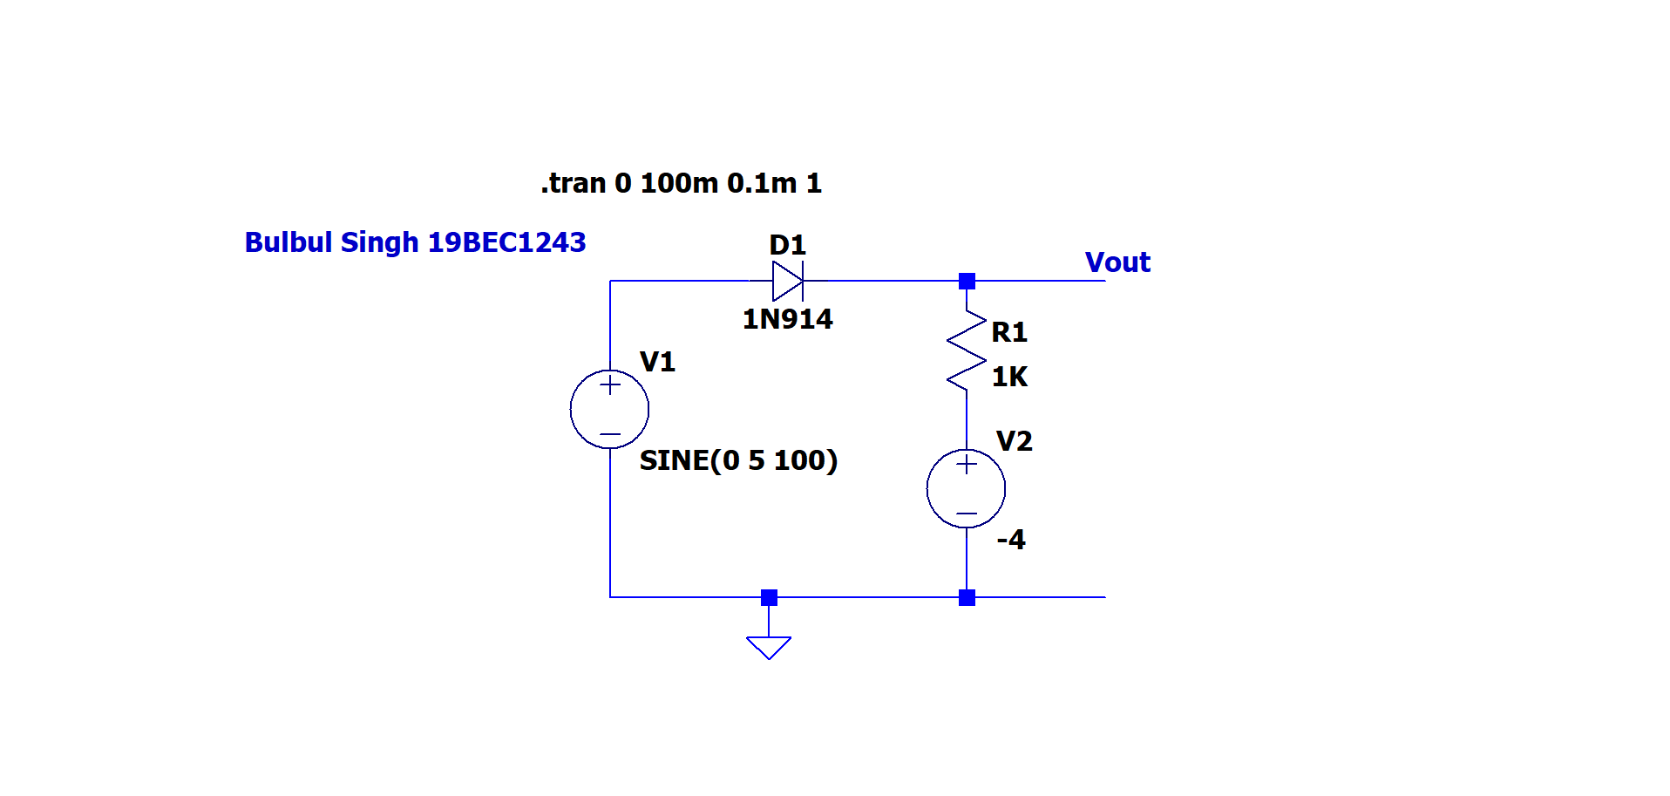

**Output:**

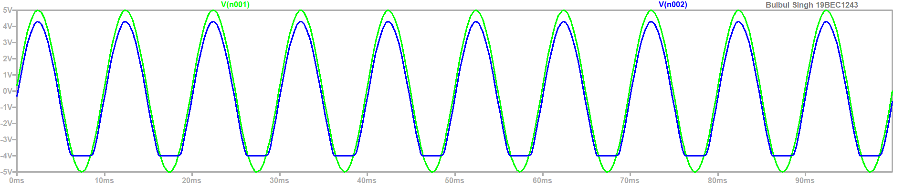

**Task 4:** Clip complete –ve cycle

**Circuit :**

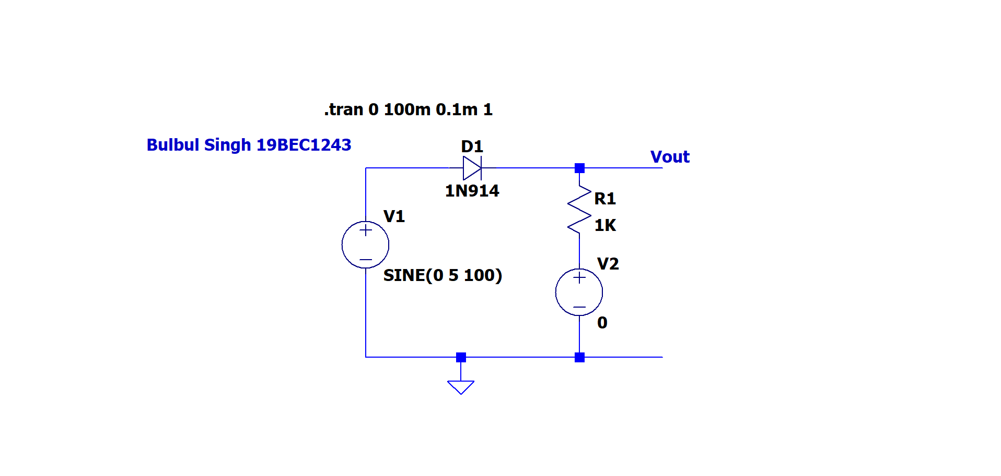

**Output:**

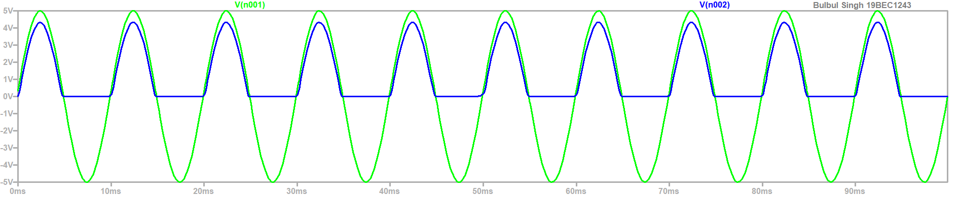

**Clampers:**

**Task 1:**

**Circuit :**

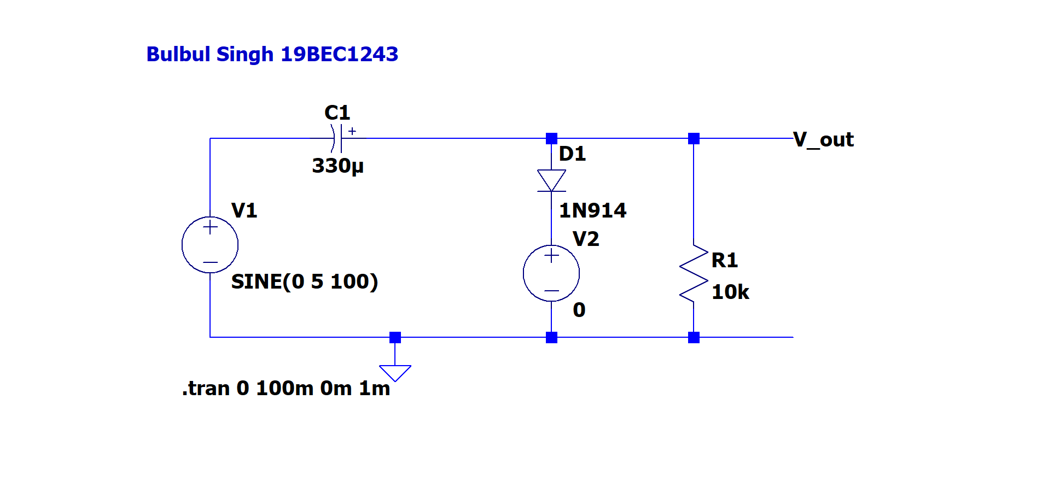

**Output:**

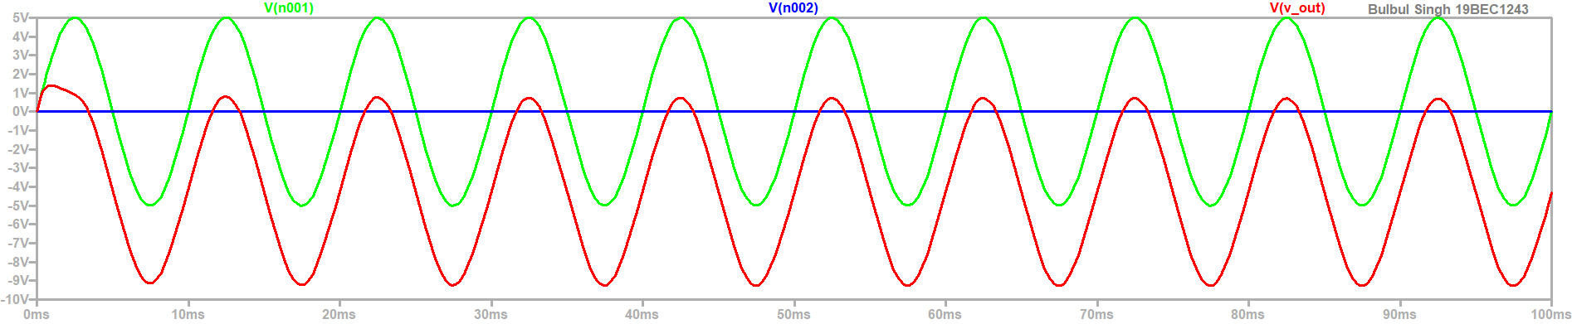

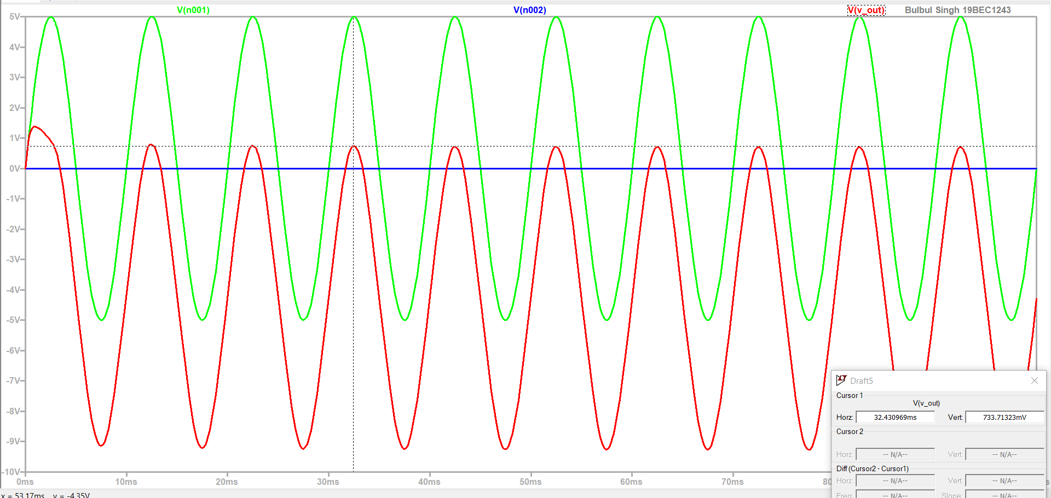

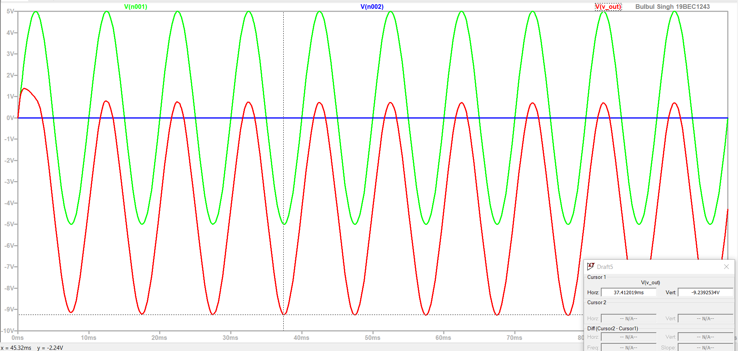

**Task 2:**

**Circuit :**

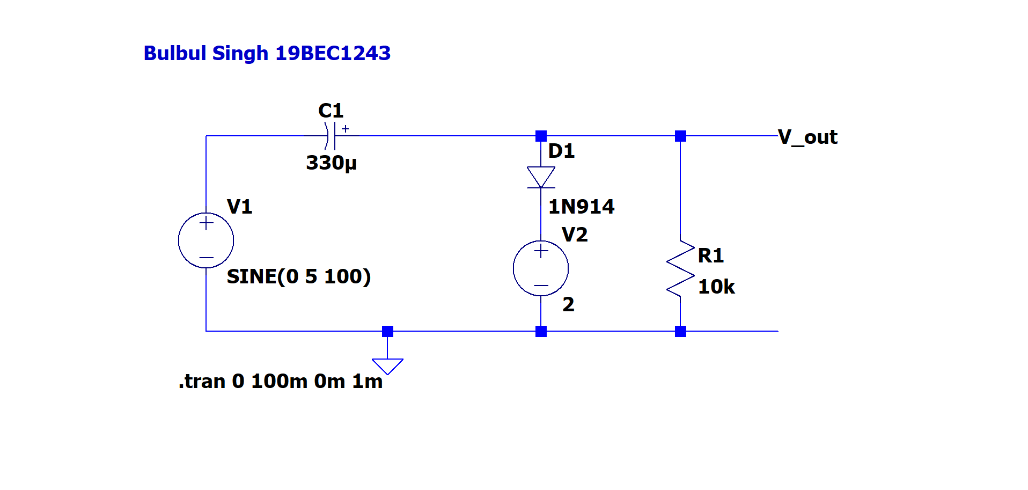

**Output:**

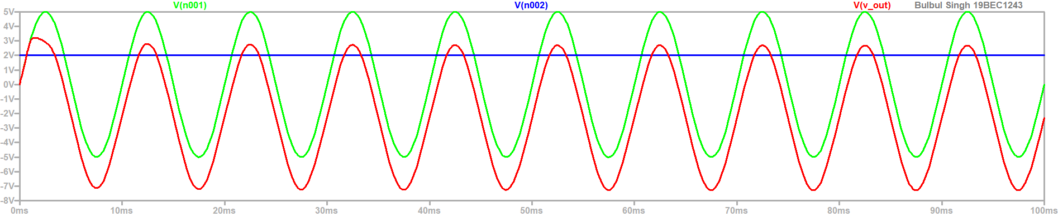

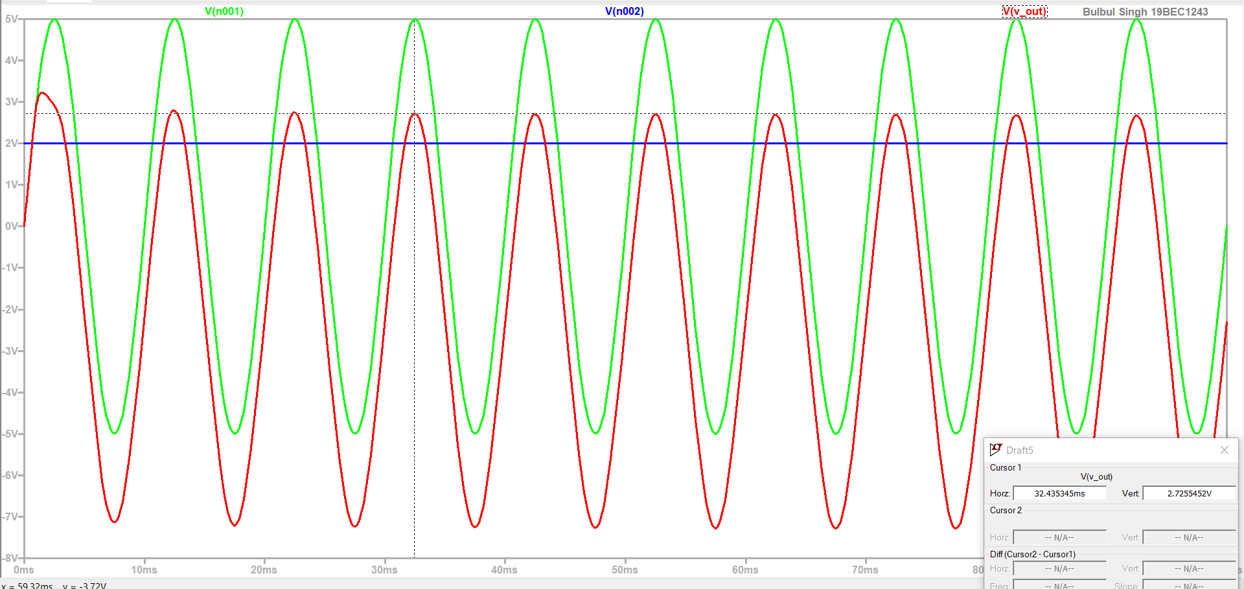

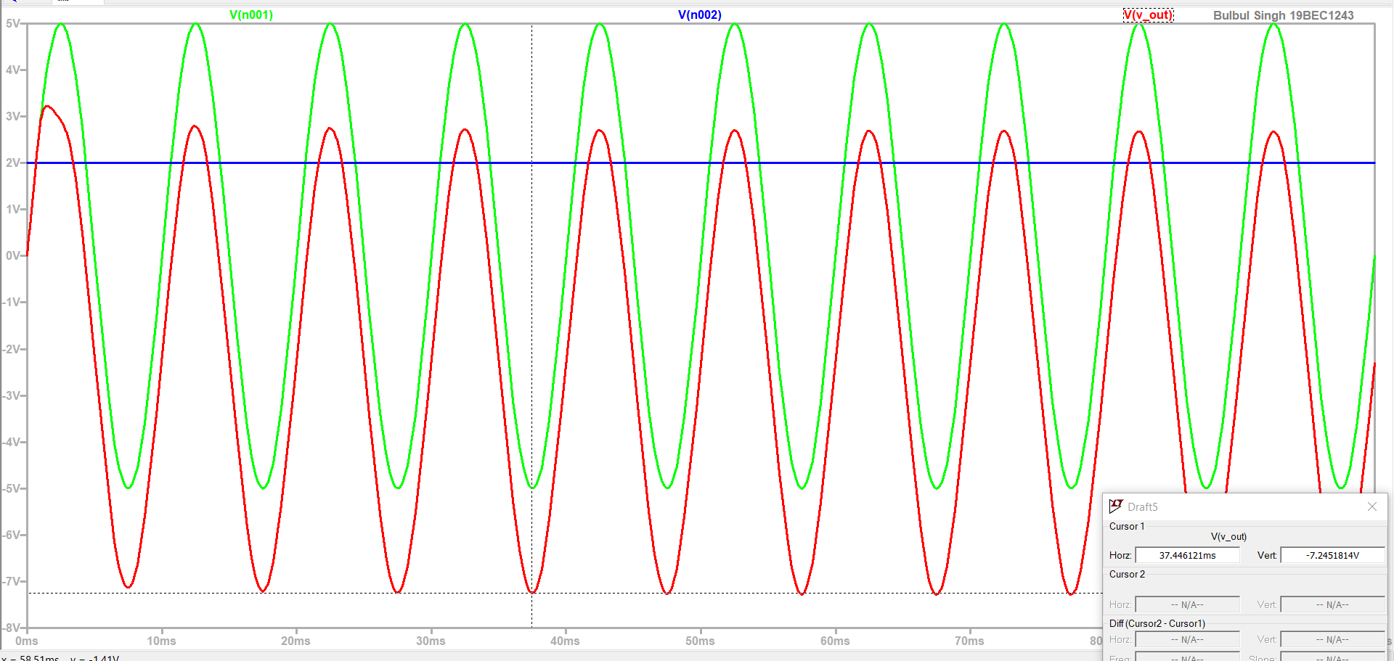

**Task 3:**

**Circuit :**

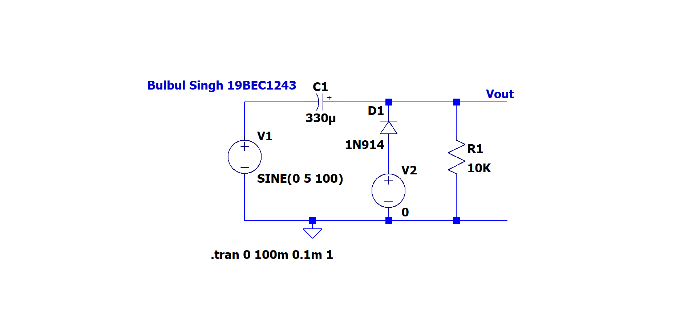

**Output:**

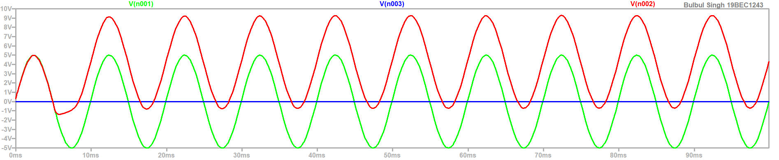

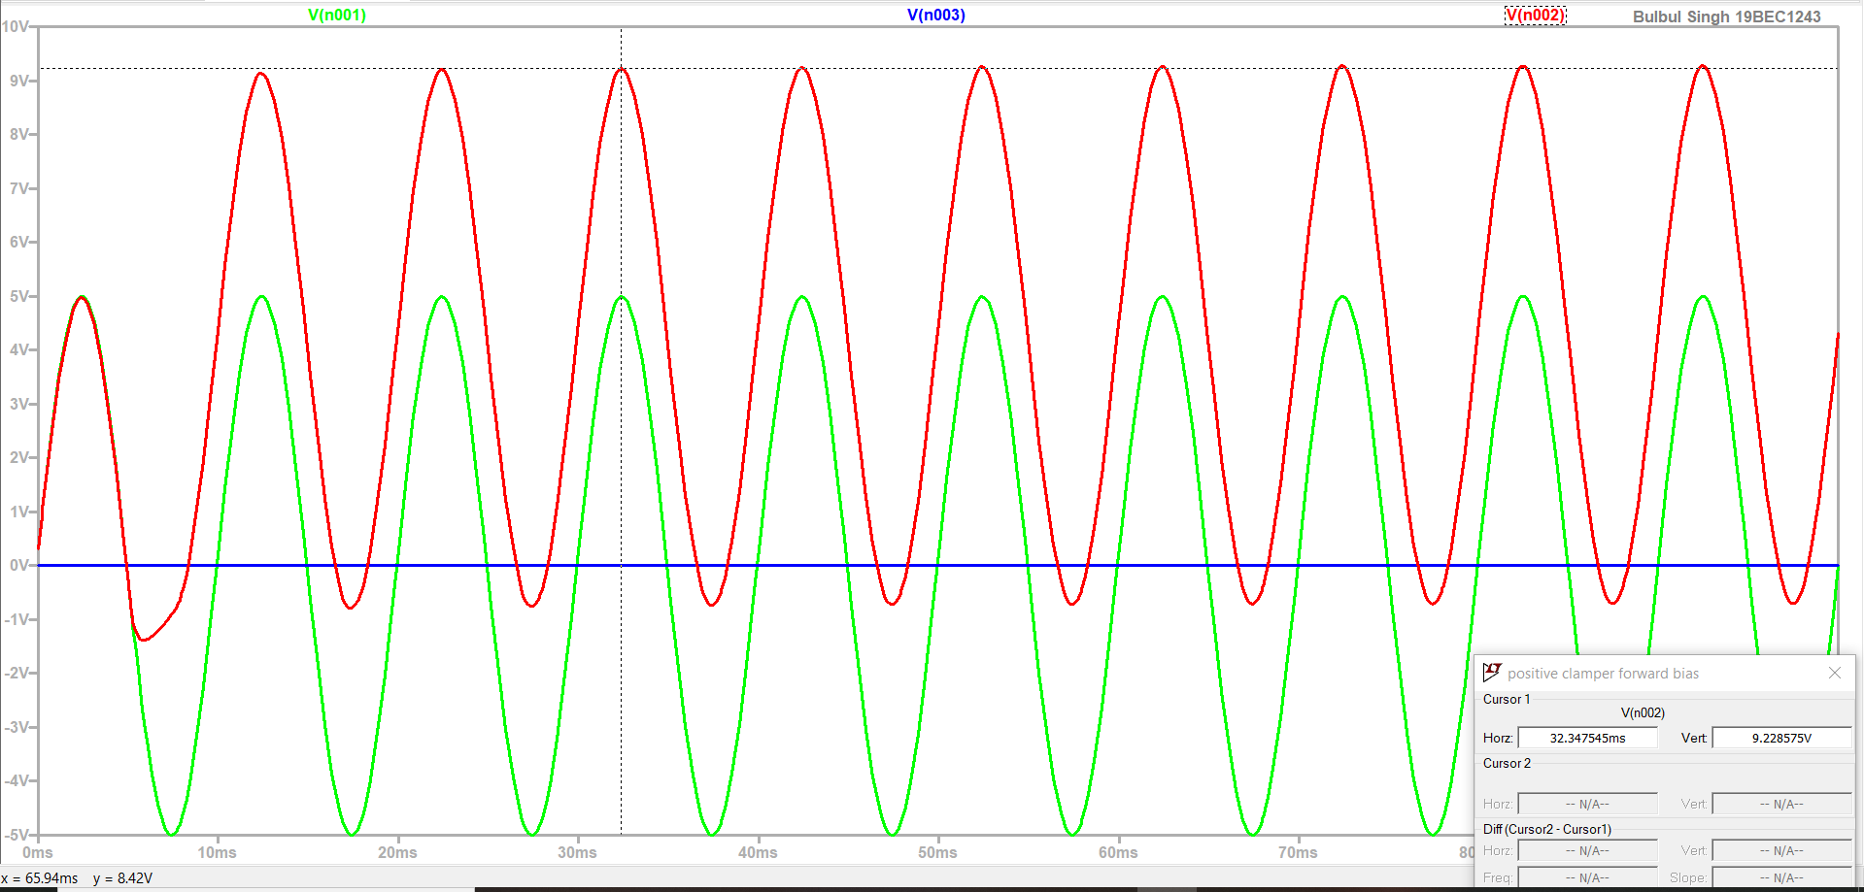

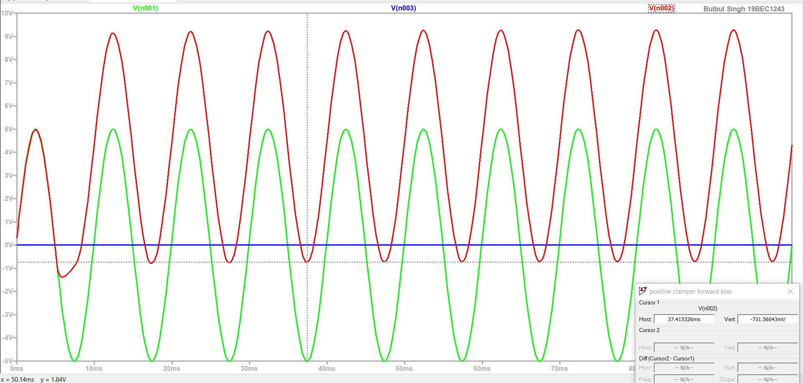

**Task 4:**

**Circuit :**

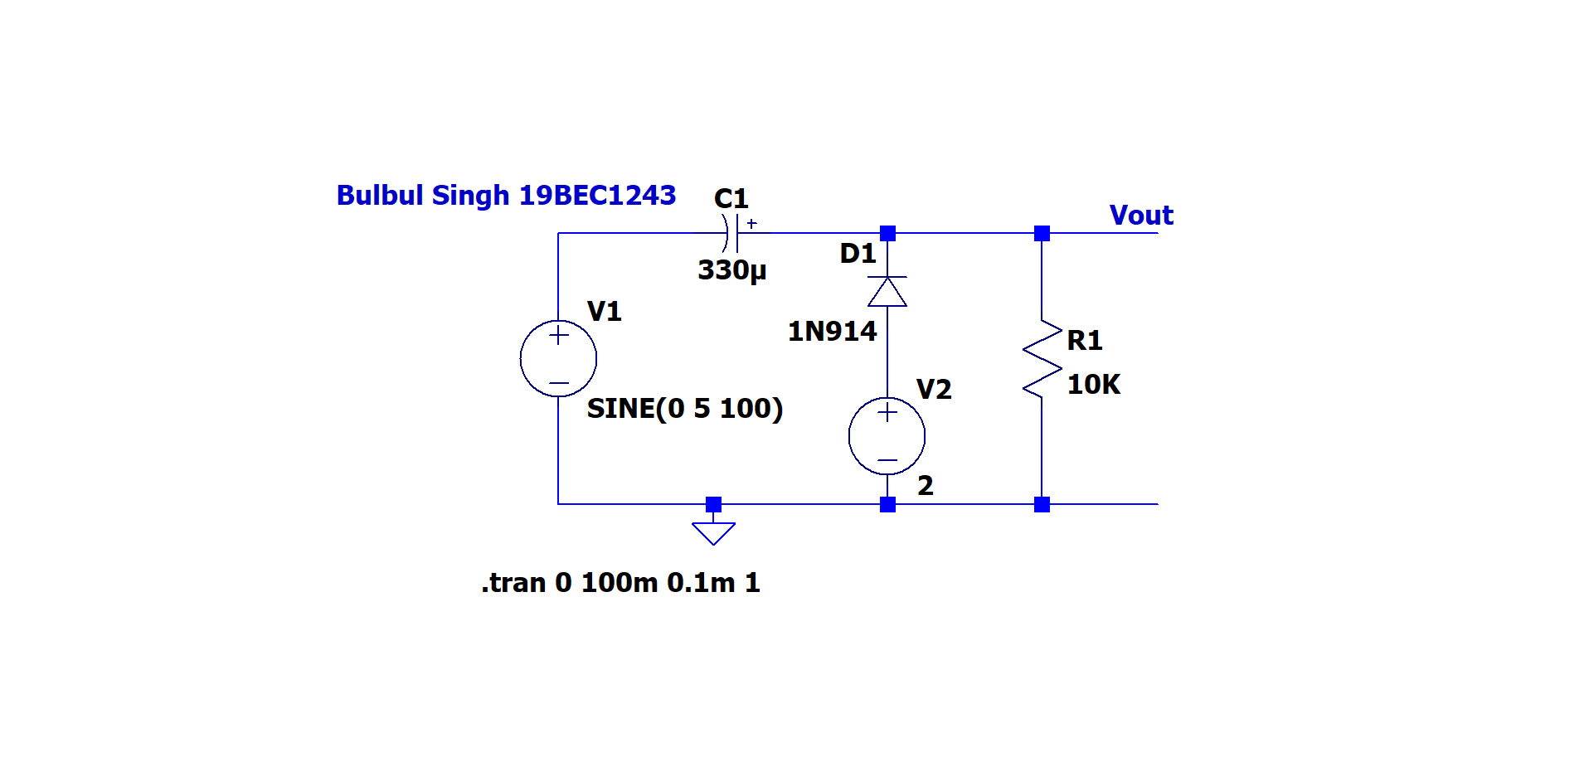

**Output:**

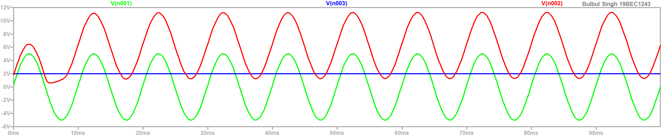

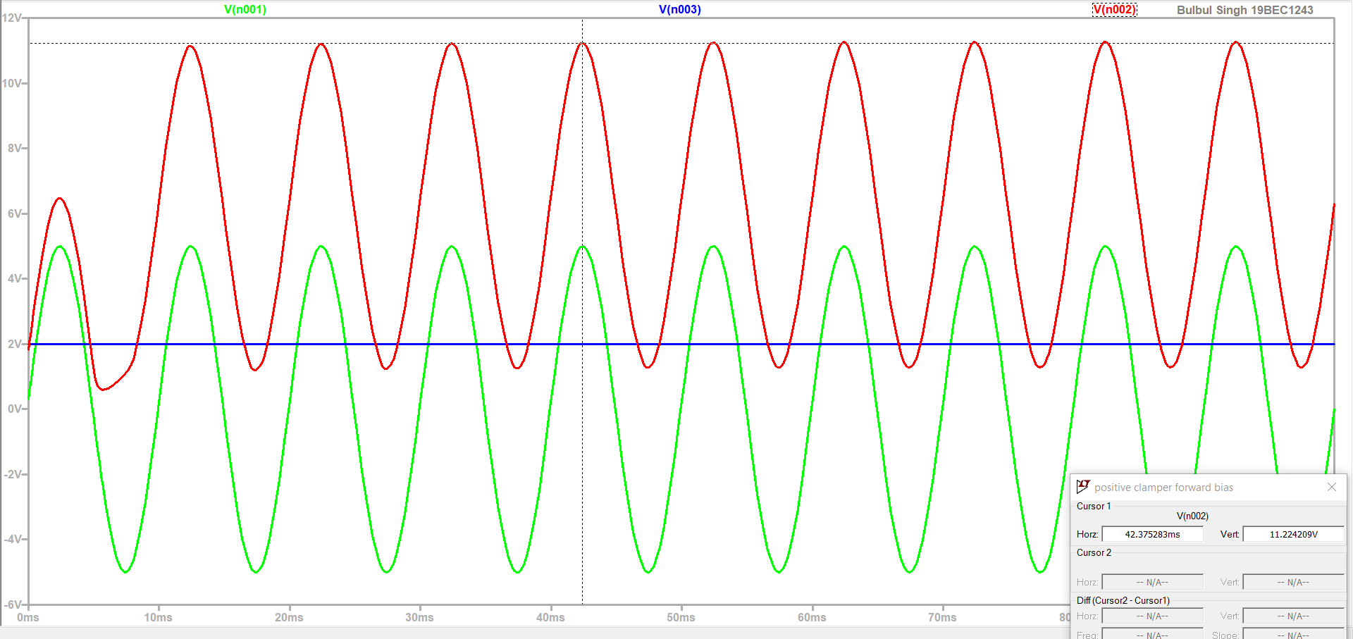

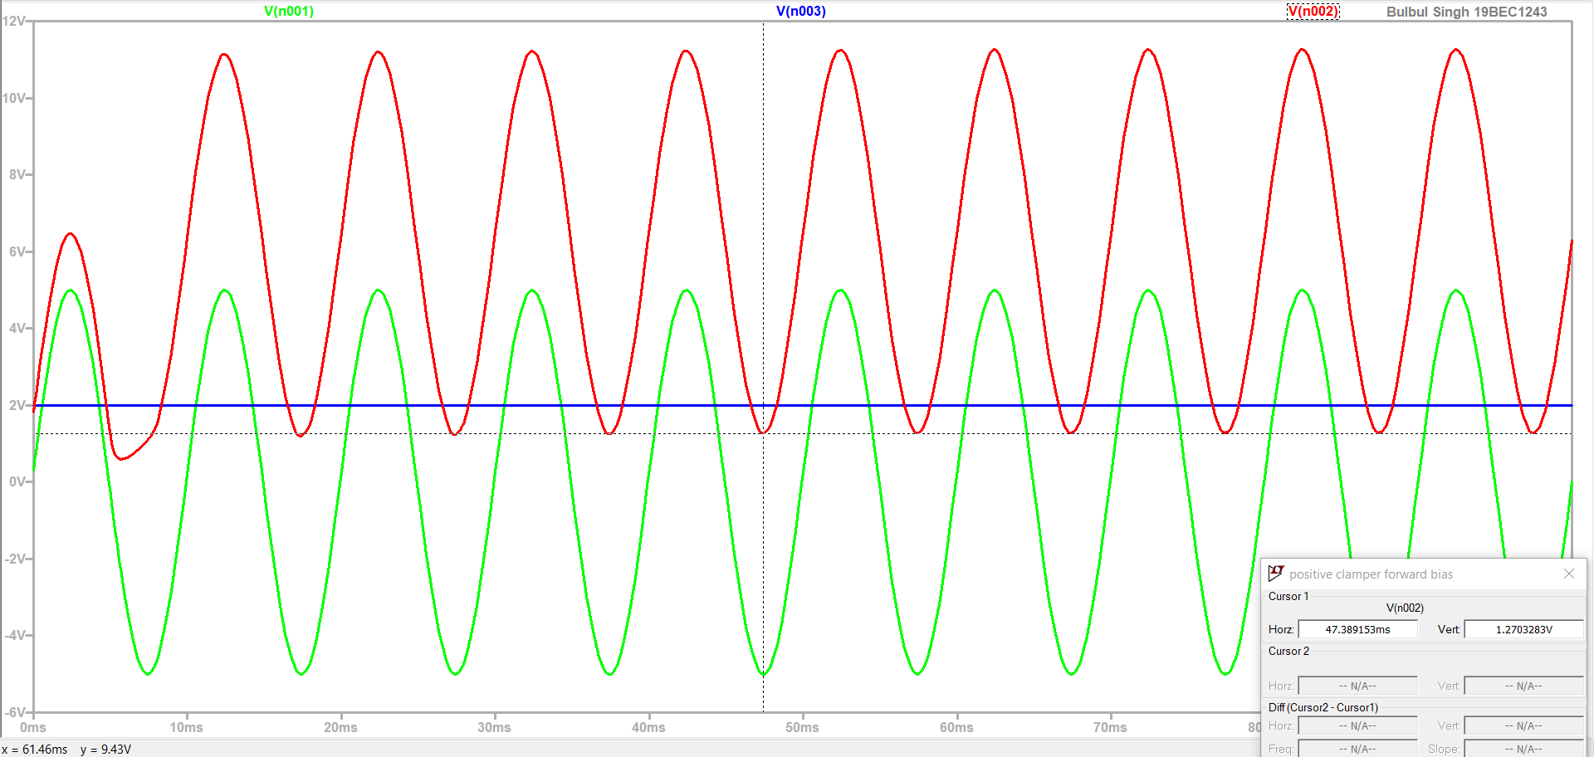

**Observation (Clampers):**

Task 1:

Change in reference value = 0.73V – 5V

= -4.27 V

Task 2:

Change in reference value = 2.75V – 5V

= -2.25 V

Task 3:

Change in reference value = 9.24V – 5V

= 4.24 V

Task 4:

Change in reference value =11.22V – 5V

= 6.22 V

|  |  |  |  |  |  |  |
| --- | --- | --- | --- | --- | --- | --- |
| **Task** | **Clamper** | **+ve Peak of 𝑽𝒊𝒏** | **+ve peak of 𝑽𝒓𝒆f** | **+ve peak of 𝑽𝒐𝒖t** | **-ve peak of 𝑽𝒐𝒖t** | **How much the reference level was shifted (volts)** |
| **1** | **Negative** | **5V** | **0V** | 0.73V | -9.24V | -4.27V |
| **2** | **Negative** | **5V** | **2V** | 2.75V | -7.24V | -2.25V |
| **3** | **Positive** | **5V** | **0V** | 9.24V | -0.72V | 4.24V |
| **4** | **Positive** | **5V** | **2V** | 11.22V | 1.27V | 6.22V |

**Conclusion:**

**Clippers:**

**Positive clipper:** From graph we can observe that the clipper circuit clips off the some part of the waveform depend on the applied reference voltage. A positive clipper clips only the positive portion(s) of the input signal.

**Negative clipper:** From the graph we can observe that a negative clipper clips only the negative portion(s) of the input signal.

**Clampers:**

**Negative clamper:** In negative clamper reference voltage will be added to the output to raise the clamped level. During the negative half cycle, the voltage across the capacitor appears at the output. Thus the waveform is clamped towards the negative portion.

**Positive clamper:** In positive clamper a diode, a resistor and a capacitor and that shifts the output signal to the positive portion of the input signal

We designed and simulated the clippers and clampers circuits using LTspice tool. Thus experiment is successfully completed.